1. Brainstorming & Ideation Phase
Brainstorm & Idea Prioritization
Team ID | SWTID-2026-1018
Team Leader | M.Madhu
Team Members | A. Priya, V. S. Sujitha, S. Priya
Project Name | Import Data using Transform Maps
Phase Description
The team discussed how employee information can be moved from an external spreadsheet into ServiceNow. The selected idea is to use Import Sets and Transform Maps to transfer the data into the required target table.
Step-by-Step Activities
Identify the problem with manual employee data entry.
Discuss a method for importing employee data into ServiceNow.
Select Import Sets and Transform Maps as the solution.
Define the expected result: accurate employee records in the target table.
Project Screenshot

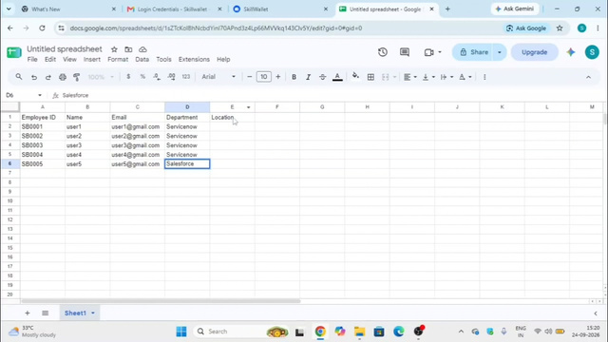

Figure 1: Source employee data prepared for the project.

